ECOM F342 COMPUTER ARCHITECTURE
ASSIGNMENT
Implement a 6-stage MIPS pipelined processor in Verilog and a forwarding unit that resolves data hazards. This processor supports load word (lw), store word (sw), jump (j), multiply (mul), and add immediate (addi). The processor should implement forwarding and stalling to resolve data hazards. The processor has Reset CLK as inputs and no outputs. The processor has instruction Fetch, Decode, Execution, Memory, and Writeback units. The processor also contains four pipelined buffers IF/ID, ID/MUL, MUL/ADD, ADD/MEM, and MEM/WB. When reset is activated, the PC, IF/ID, ID/MUL, MUL/ADD, ADD/MEM, and MEM/WB registers are initialized to 0, the instruction memory and register file get loaded by predefined values. The pipeline registers contain unknown values when the instruction unit fetches the first instruction. When the second instruction is fetched in the IF unit, the IF/ID registers will hold the instruction code for the first instruction. When the third instruction is being fetched by the IF unit, the IF/ID register contains the instruction code of the second instruction, the ID/EX1 register contains information related to the first instruction, and so on. (Assume Address and Data size is 32-bits)

The instruction and its 32-bit instruction format are shown below:

lw destinationReg, offset(sourceReg)
Sign extends the offset to 32-bits, adds it to sourceReg, and stores the data corresponding to the memory location defined by the calculated address in the destinationReg. The opcode for lw is 100011
opcode | rs(sourceReg) | rt(destinationReg) | imm(offset)
6 bits(31:26) | 5 bits (25:21) | 5 bits (20:16) | 16 bits (15:0)

sw sourceReg1, offset(sourceReg2)
Stores the contents of sourceReg1 to the memory address calculated by sign extending the data specified in instruction field (15:0) to 32-bits and then adding it with register specified by register number in sourceReg2. The opcode for sw is 101011.
opcode | rs(sourceReg2) | rt(sourceReg1) | imm(offset)
6 bits (31:26) | 5 bits (25:21) | 5 bits (20:16) | 16 bits (15:0)

j address
Jumps to the address calculated by concatenating the 4 bits of the PC and the specified address, then left shifting it by 2 bits. The opcode for j is 000010.
opcode | address
6 bits (31:26) | 26 bits (25:0)

mul destinationReg, sourceReg1, sourceReg2
Multiply (without overflow). Result is only 32bits. Stores the multiplication of sourceReg1 and sourceReg2 in destinationReg. Opcode of mul is 000000, shamt is 00000, and the funct for mul is 011000.
opcode | rs(sourceReg1) | rt(sourceReg2) | rd(destinationReg) | Shamt | funct
6 bits (31:26) | 5 bits (25:21) | 5 bits (20:16) | 5 bits (15:11) | 5 bits (10:6) | 6 bits (5:0)

addi destinationReg, sourceReg, immediate value
0-extends the offset to 10-bits. Shift right by offset number of bits. The opcode for addi is 000001. The funct is 000010
opcode | rs(sourceReg) | rt(destinationReg) | Immediate value | funct
6 bits(31:26) | 5 bits (25:21) | 5 bits (20:16) | 10 bits (15:6) | 6 bits (5:0)

If the instruction is mul instruction, then the results from the addition stage have to bypass (contents of MUL/ADD register have to be directly transferred to ADD/MEM register without undergoing addition) the addition stage and then should proceed to memory in the pipeline. Similarly, addi instruction should bypass (contents of the ID/MUL register have to be directly transferred to MUL/ADD register without undergoing multiplication) the multiplication stage in the pipeline.

Assume the register file contains 32 registers (R0-R31). Each register can hold 32-bit data. All registers in the register file should be set to zero on reset. Ensure r0 is always zero. Each location in DMEM has 8-bit data. So, to store a 32-bit value, you need 4 locations in the DMEM, stored in big-endian format. On reset, the first location in DMEM, DMEM[0], should be initialized to the decimal number 9 and DMEM[1], should be initialized to the decimal number 1. On reset, ensure that the instruction memory gets initialized with the following instructions, starting at address 0:

lw r1, 0(r0)
lw r2, 1(r0)
mul r1,r1,r2
j L
mul r2, r1,r2
L:
addi r4, r1, 3
sw r4, 4(r0)

The above code should run correctly on the processor implementation. Ensure that you handle the data hazards present, if any. A partial block-level representation of a 5-stage pipelined processor is shown below:
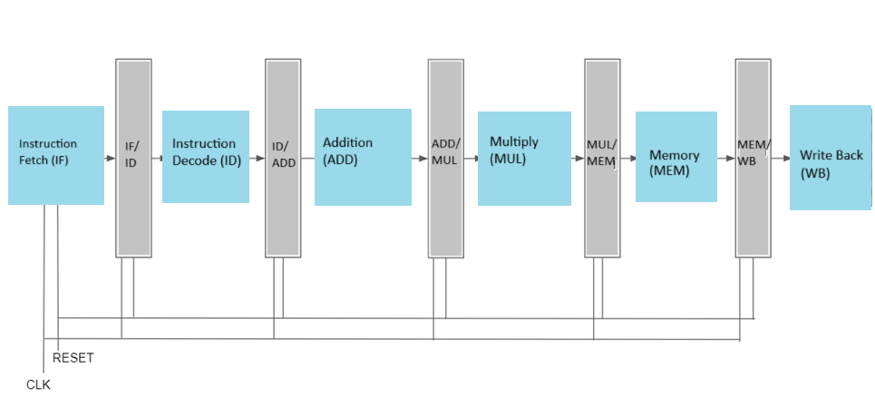

As part of the assignment, three files should be submitted in a zipped folder.
1. PDF version of this document with all the Questions below answered in a pdf file name, IDNO_NAME.pdf.
2. Design Verilog Files for all the sub-modules.
3. Design a Verilog file for the main processor.
The name of the zipped folder should be in the format IDNO_NAME.zip
______________________________________________________________________________
Name: Click here to enter text. ID No:

Questions Related to Assignment
- Draw the complete Datapath and show control signals of the 5-stage pipelined processor.

Answer:

- List the control signals used and the control signals’ values for different instructions in a tabular format as follows:

Answer:
Instructions | Control Signals
Lw
Sw
J
Mul
addi

- Implement the Instruction Fetch block. Copy the image of the Verilog code of the Instruction fetch block here

Answer:
- Implement the Instruction Decode block. Copy the image of Verilog code of the Instruction decode block here

Answer:
- Implement the Register File and copy the image of the Verilog code of the Register file unit here.

Answer:
- What is the data hazard in the given instruction snippet? Determine the condition that can detect the data hazard in the given instruction snippet.
Answer:
- Implement the forwarding unit and copy the image of the Verilog code of the forwarding unit here.

Answer:
- Implement the complete processor in Verilog (using all the Datapath blocks). Copy the image of the Verilog code of the processor here. (Use comments to describe your Verilog implementation)

Answer:
- Test the processor design by generating the appropriate clock and reset. Copy the image of your testbench code here.

Answer:
- Verify if data memory is updated according to the set of instructions (mentioned earlier). Copy the image of the waveform of DMEM, CLK, and RESET. Show only those DMEM addresses that are updated in those instructions.
Answer:
- What is the total number of cycles needed to issue the program given above on the pipelined MIPS Processor? What is the CPI of the program?
Answer:
- Make a diagram showing the clock by clock execution of each instruction, indicating stalling, forwarding etc wherever necessary.
Answer:

13. In a program, there are 25% load instructions, 1/x of which are immediately followed by an instruction that uses a result, requiring a stall. 10% are stores. 50% are R-type. 10% are branch, 1/y of which are taken. 5% are jumps. What is the average CPI of this program? If the number of instructions are 10^9, and the clock cycle is 100 ps, how much time does a MIPS single cycle pipelined processor take to execute all instructions? Assume the processor always predicts branch not-taken.
Where x, y, z are related to last 3 digits of your ID No.
If ID number: 20XXXXXXABCG, then x = (A % 8) + 1, y = ((B + 2) % 8) + 1, and z= ((C + 3) % 8) + 1.
Answer:
14. Do you think stall is needed? Can it be solved by forwarding? Show where stall is necessary.
Answer:
15. Your design synthesisable? Which target FPGA was used for synthesis?
Answer:
16. Provide the synthesis report in tabular form (resources consumed)?
Answer:
Unrelated Questions
What were the problems you faced during the implementation of the processor?
Answer:
Did you implement the processor on your own? If you took help from someone, whose help did you take? Which part of the design did you take help for?
Answer:

Honor Code Declaration by student:

- My answers to the above questions are my own work.
- I have not shared the codes/answers written by me with any other students. (I might have helped clear doubts of other students).
- I have not copied others’ code/answers to improve my results. (I might have got some doubts cleared by other students).

Name: Date:
ID No.:

